Liver Cleanse & Detox

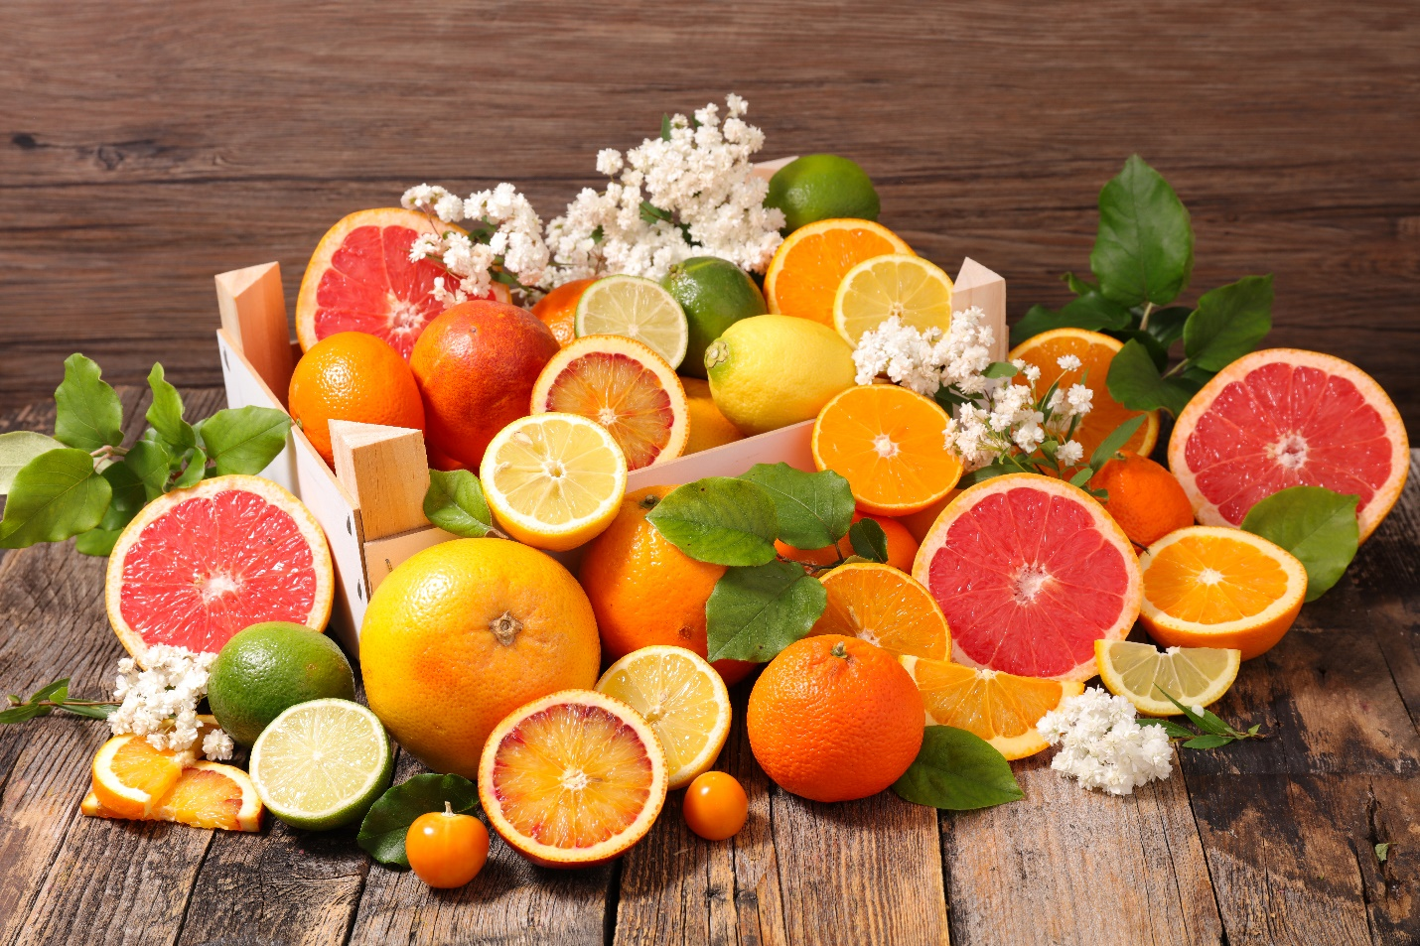
This one is very yummy , only issue : you may smell like a Mediterranean Salad because of the garlic which removes the heavy metals from the body . The way this detox works with the 3 full tablespoons of Olive oil + the Cayenne pepper(I buy the cayenne in capsules then swallow the capsules with the yummy orange & lemon fresh juice ) is that the oil pulls the garlic & cayenne to the liver so the liver and gallbladder Cleanse , you may need to lay on your right side for a bit in case you began to feel like you’re going to toss the mixture ! the good news is this cleanse is so effective you can feel it working right away !
The Recipe: Juice of 2 oranges and 1 lemon ( fresh squeezed please :0.. 5 to 6 cloves of garlic ( can increase as tummy allows I am up to 10 cloves )
3 full tablespoons olive oil add ¼ to ½ teaspoon cayenne pepper put all the ingredients in blender spin until garlic is smooth. This drink taste very yummy
Have a cup of somekinda detox tea, wait 45 min and eat your normal breakfast . I would stay away from processed food. this will help the detox to work better. do at least 3 days .. more if needed
Bon`Appetit

